*Display your age in months and days.

-select round(sysdate-to_date('02-06-1997'))days from dual;

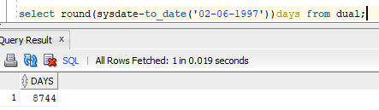

-Select round(months_between(sysdate,'02-06-1997')) months from dual;

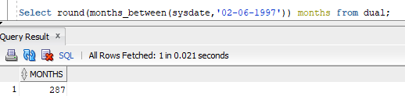

*Display Independence day date in Words.(15th August Nineteen Forty Seven)

- select to_char(to_date('15-08-1947','dd-mm-yyyy'),'ddth month year')words from dual;

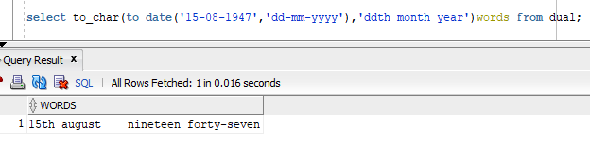

*Split the word **"shiva sai shankar"** into first, middle and last names.

-select substr('shiva sai shankar',1,instr('shiva sai shankar',' ')-1) first_name,

substr( 'shiva sai shankar',instr('shiva sai shankar',' ')+1,instr('shiva sai shanka',' ',1,2)-instr('shiva sai shanka',' ')-1 ) middle_name,

substr('shiva sai shanka',instr('shiva sai shanka', ' ',1,2)) last_name from dual;

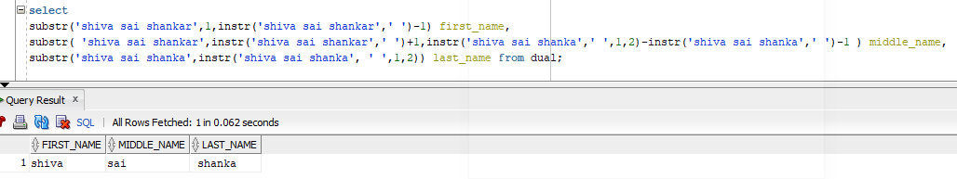*Implement to_date,to_char, sysdate, timestamp,add_months, months_between, next_day, currentdate, etc...

-select to_date('2010-01-05', 'yyyy-mm-dd')

(or)

-select to_date('05-01-2020','dd-mm-yyyy')

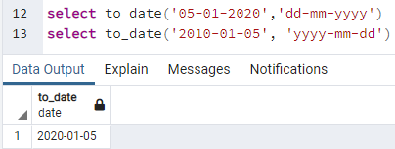

-select to_char(sysdate,'ddth month day year') from dual;

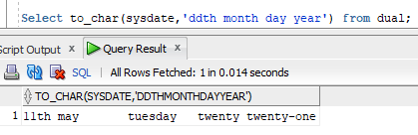

- select current_timestamp from dual;

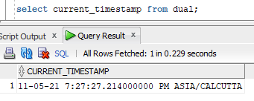

-select localtimestamp from dual;

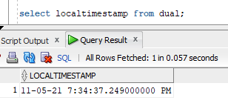

-select add_months('11/08/2021',6) from dual;

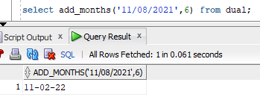

- select months_between('11/08/2021','11/02/2021') monthsdifference from dual;

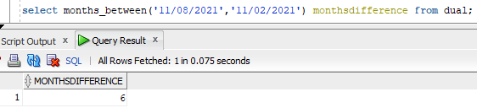

-select next_day('11/08/2021','friday') monthsdifference from dual;

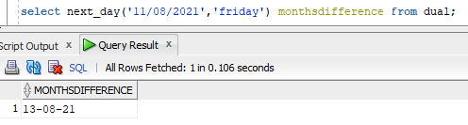

- select last_day('11/09/2021') from dual;

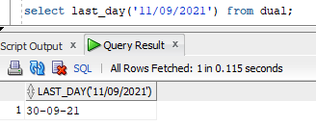

*Write a SQL Query which includes all basic keywords and explain with steps for **Order of Execution**

-Select count(id),comm from emp group by comm having count(id)>5 order by count(id) desc;

From,includingjoins,where,groupby,having,windowfunctions,select,distinct,union,orderby,limit and offset.

-select substr('capacitor',4,5) from dual;

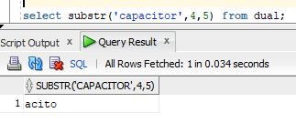

-select instr('capacitor','c',2) from dual;

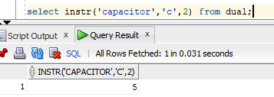

-select trim('l' from 'hello') from dual;

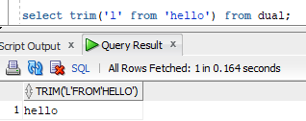

-select round(90.3444,1) from dual;

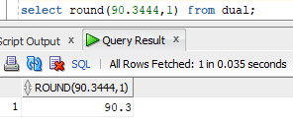

-select trunc(90.3444,3) from dual;

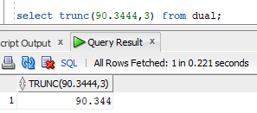

-select replace('jack and jue','j','bl') from dual;

